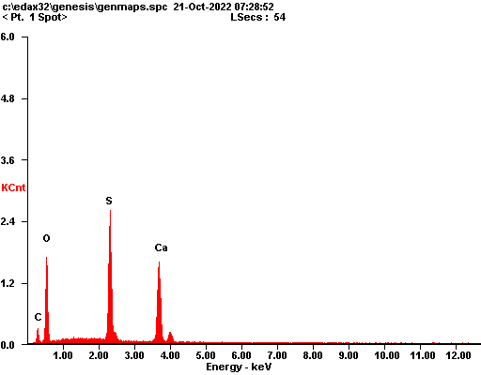

|  |  |  |
| --- | --- | --- |
| ***Element*** | ***Wt%*** | ***At%*** |
| ***CK*** | 09.05 | 16.12 |
| ***OK*** | 40.20 | 53.76 |
| ***SK*** | 22.73 | 15.17 |
| ***CaK*** | 28.01 | 14.95 |
| ***Matrix*** | Correction | ZAF |

